

American International University-Bangladesh (AIUB)  
**Department of Computer Science  
Faculty of Science &Technology (FST)  
Spring 20 21**

**<** **Psychological Automation Quiz Test >**

Software Requirement Engineering

Sec: **A**

Project submitted By

*Saikat Baul (18-36193-1)*

*Sakimul Karim Adan (18-36622-1)*

*Amit Paul (17-34918-2)*

*Rakib Ahmed (18-37964-2)*

Under the supervision of

*Abhijit Bhowmik*

Associate Professor

Facculty of Science & Techonology

American International University-Bangladesh

**Table of Contents**

1 PROBLEM DOMAIN 4

1.1 Background to the Problem 4

1.2 Solution to the Problem 4

1.2.1 Our Solution VS Others Solution 4

2 SOLUTION DESCRIPTION 4

2.1 System Features 4

2.1.1 Functional Requirement 4

2.1.2 Other non-Functional Requirements 6

2.1.3 Software Quality Attribute 7

2.1.4 Security Attribute 8

2.2 UML Diagrams 9

3 Social Impact 9

4 Development Plan 10

4.1 What is SDLC? 10

4.1.1 Planning and Requirement Analysis. 11

4.1.2 Defining Requirements 11

4.1.3 Designing the Product Architecture 11

4.1.4 Building or Developing the Product 11

4.1.5 Testing the Product 11

4.1.6 Deployment in the Market and Maintenance 12

4.2 Software Requirement Specification 12

4.2.1 What is SRS? 12

4.2.2 User Sope 12

4.2.3 Moderator Scope 13

4.2.4 Admin Scope 13

4.2.5 Constraints And Dependencies 13

4.2.6 User Interface 13

4.2.7 Admin Panel Interface 13

4.2.8 Communication Interface 13

4.2.9 Project Position in the System Life Cycle 14

4.3 Testing 14

4.3.1 Features to be Tested 14

4.3.2 Features not to be tested 14

4.4 Tools And Technology Used 15

4.4.1 Apache Web Server 15

4.4.2 MySQL Database 15

4.4.3 Php 15

4.4.4 Xampp 15

4.4.5 Sublime 15

4.4.6 Responsive Template 16

4.4.7 Operating System 16

4.4.8 Google Docs 16

4.4.9 Día 16

4.4.10 Microsoft SQL Diagram 16

4.4.11 Browser 16

4.4.12 GitHub 17

4.5 Work Breakdown Structure and Schedule 17

4.5.1 Work Breakdown Structure 17

4.5.2 Schedule 18

5 Marketing Plan 18

5.1 Define goals 18

5.2 Target audience 18

5.3 Marketing Tactics 18

6 Cost and Profit Analysis 19

6.1 Cost Analysis 19

6.2 Profit Analysis 19

7 Conclusion 19

8 Referenced Documents 20

# PROBLEM DOMAIN

## Background to the Problem

In our daily office life, most of the time we work as a team for a particular task. There are lots of teams working into the same project. Making an effective team is a key feature for project success. We are not machines; we act based on our mentality. That is why making a team where everybody's mentality is the same, boosts our working experience.

## Solution to the Problem

When it has come to choose the same mentality people there is only one way by taking a psychological test. We build our website based on this psychological test. Our test is a simple multiple choice quiz test. We have our several types of quiz questions. After finishing every quiz people get a score. It measures their mentality. Same score people are going to the same team. Our quiz questions are randomly selected for a participant. There is no wrong or right answer for each question. People can choose any answer. Based on that answer our system will select the next question automatically. Every question has half minute to answer. Participants cannot skip any question. We store every participant score to their account.

### Our Solution VS Others Solution

Most of the quiz tests are based on individual psychological tests online. Also, you can give those tests for your own good. As an example, if somebody wants to buy a car but cannot decide what color he/she wants. Giving a psychological test decides the percentage for each choosing color. This is the main difference between our website and other websites. We work on a particular team or group on our website. On our website we try to measure physiological scores for each team member. After this test they find out their comfort to each other based on their psychological test score. If they are at the same comfort level then they can work together or if not, they are not suitable for working together.

# SOLUTION DESCRIPTION

## System Features

### Functional Requirement

* Database Creation.
* Page Segment.
* Showing Quiz Set by Category.
* Adding Search Functionality with dynamic keyword auto suggestion.
* Dynamic Admin Template.
* Creating Session Class.
* Admin Login Authentication Admin Logout Option.
* Update Session Class.
* Showing Quiz Set Categories in Admin Panel.
* Add Quiz Set Categories from the Admin Panel.
* Update Quiz Set Categories from Admin Panel.
* Delete Quiz Set Categories from Admin Panel.
* Add Each Quiz Set from the Admin Panel.
* Showing Each Quiz Set in the Admin Panel.
* Showing Each Quiz Set in the Edit Page.
* Update Each Quiz Set Post with Condition.
* Delete Posts from Admin Panel Table for Logo, Title, Slogan.
* Update Logo, Title, Slogan.
* Update Social Media Option.
* Update Copyright Option.
* Dynamic Page Creation.
* Update Page Dynamically.
* Delete Page Dynamically.
* Showing Pages Dynamically.
* Dynamically Displaying Page.
* Each Quiz Set Title in header .php.
* Highlight Current Page or Menu Item.
* Contact Form Validation.
* Work With Contact Form Validation Details.
* Work With Inbox.
* Viewing Sent Messages.
* Reply messages.
* Send Messages to the Seen Box.
* Delete Messages from Seen Box.
* Notification for incoming messages.
* Adding Meta Keywords Tags to Individual Post.
* Add User to Assign Roles.
* Update User Profile.
* Display Showing User List.
* View User Details User Roles and Permissions.
* Role Based Access Control.
* Account activation by email, using PHPMailer PHP library.
* PHP Remember me functionality.
* Secured Password hashing with PHP hash algorithm.
* PHP Password Reset / recovery by email system.
* Protecting Against CSRF Attack with Unique Secured PHP Token Generation.
* Change Password using PHP.
* Deactivate Account using PHP.
* Automate Task with Cron Job using PHP.
* Blocking Bots and Spammers with reCAPTCHA.
* Constantly update mostly based on genuine requests from Participants.
* Truck Participant Mental recorded based on their score.
* Set a remainder function.
* Sorting function create (lowest to highest).
* Create a user friendly Phycological Quiz Test template.
* Make our website responsive.

### Other non-Functional Requirements

Non-functional means it does not directly impact the project but without those functions our project will be incomplete.

* Usability requirement: Usability requirements are documented expectations and specifications designed to ensure that a product, service, process, or environment is easy to use.
* Serviceability requirement: Serviceability requirements are a set of conditions under which a foundation structure is useful.
* Manageability requirement: Manageability is the ability to manage the system to ensure the continued health of a system.
* Recoverability requirement: The recovery requirements are developed for the critical business processes identified in the business impact analysis. They help identify the resources that should be the focus of the recovery strategy since there is a cost involved with developing and implementing a mitigation or recovery strategy.
* Security requirement: A security requirement is a security feature required by system users or a quality the system must possess to increase the users trust in the system they use.
* Data Integrity requirement: Data Integrity is a critical requirement, which is defined in many ways. The Technopedia.com definition of Data Integrity linked here focuses on three key attributes: completeness, accuracy, and consistency.
* Capacity requirement: Capacity requirements planning is the process by which a website figures out how much it needs to produce, and determines if it can meet those production goals.
* Availability requirement: For the purposes of this report an Availability Requirement is any requirement that is not a functional, data or process requirement concerned with defining the periods when the solution can be used.
* Scalability requirement: Scalability refers to the ability of the environment to meet the needs of an increasing number of users and external services in a way that is predictable in terms of performance.
* Interoperability requirement: A definition of interoperability is the ability to share information and services.
* Reliability requirement: A reliability requirement is a prediction or forecast of the performance of the product in the future. Reliability is usually defined as the probability that a product will operate without failure for a specified number of uses (transactions) or for a specified period.
* Maintainability requirement: Maintainability is the ease with which faults in a software system can be found and fixed. ELICITATION: Maintainability requirements address the user concern for how easy it is to upkeep and repair the system.

### Software Quality Attribute

* **Reliability:** Measure if the software is reliable enough to sustain in any condition. Should give consistently correct results. Software reliability is measured in terms of working of the project under different working environments and different conditions.
* **Maintainability**: Different versions of the software should be easy to maintain. For development it should be easy to add code to the existing system, and should be easy to upgrade for new features and modern technologies from time to time. Maintenance should be cost-effective and easy. The system is easy to maintain and correcting defects or making a change in the software.
* **Usability:** This can be measured in terms of ease of use. The application should be user-friendly. Should be easy to learn. Navigation should be simple. The system must be: Easy to use for input preparation, operation, and interpretation of the output. Provide consistent user interface standards or conventions with our other frequently used systems. Easy for new or infrequent users to learn to use the system.
* **Portability:** This can be measured in terms of Costing issues related to porting, technical issues related to porting, Behavioral issues related to porting.
* **Correctness:** The application should be correct in terms of its functionality, calculations used internally and the navigation should be correct. This means the application should adhere to functional requirements.
* **Efficiency:** Major system quality attribute. Measured in terms of time required to complete any task given to the system. If the system is not efficient then it cannot be used in real-time applications.
* **Integrity or Security:** Integrity comes with security. System integrity or security should be sufficient to prevent unauthorized access to system functions, preventing information loss, ensure that the software is protected from virus infection, and protecting the privacy of data entered the system.
* **Testability:** The system should be easy to test and find defects. If required it should be easy to divide into different modules for testing.
* **Flexibility:** Should be flexible enough to modify. Adaptable to other products with which it needs interaction. Should be easy to interface with other standard 3rd party components.
* **Reusability:** Software reuse is a good cost-efficient and time-saving development way. Different code libraries classes should be generic enough to use easily in different application modules. Dividing application into different modules so that modules can be reused across the application.

Applying above quality attributes standards we can determine whether the system meets the requirements of quality or not.

### Security Attribute

* Each participant has a unique id to distinguish him/her.
* Each room quiz test has a unique room id.
* Each participant can edit/update/delete their account.
* Auto logout option.
* Participants can see all blog posts.
* Moderator, admin will have two step verifications for log in.
* Forget password option.
* We use SSL which is a digital certificate that encrypts information sent between a web server and web browser. It is one of the most effective ways to achieve data security on our website and to keep our participant data protected.
* We Use a Real-Time Bot Detection Technology to eliminate price scraping and other Online frauds.
* We use a web application security system for network level security. Waf protects websites from common attacks such as cross-site scripting (XSS), SQL injections and DDos attacks. Since websites have a lot of inbound traffic, they need firewalls to protect themselves against malicious entry. The two highly effective firewalls for websites are application gateways and proxy firewalls.
* We use object oriented php for more security.
* We have a system in place for purging participant data.
* We Insist on participants using strong passwords by pop up notification.

## UML Diagrams

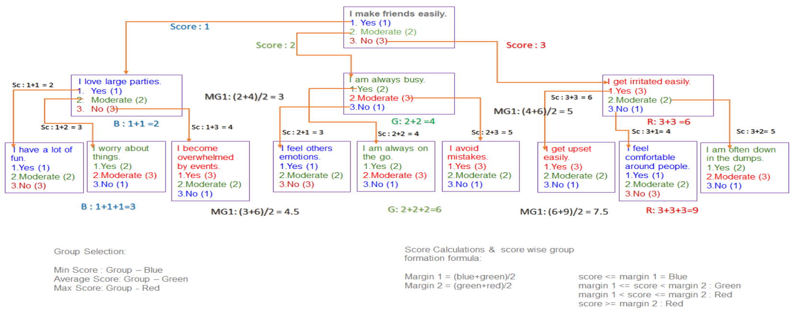

Figure 1: Software Visual Architecture

In figure 1 we can see our question pattern. We already know our quiz test is different from other same category quiz tests. In this case the question comes one after another based on the previous question answer. This does not impact their total score. As an example, we can say that if someone hairs uber moto to go to his/her destination on other hand someone hairs pathao moto to go to the same destination then there is no difference. It is simply their personal choice. Or we can say it is their comfort zone. Our website exactly works like that. If someone likes football, they get football related questions but if someone likes traveling, they get traveling related questions. At the result this creates no impact for their total score. Every participant can give their quiz test with their personal comfort.

# Social Impact

Moving assessments online may seem a daunting task, however the benefits online testing provides should be a good motivator for most teachers and instructors. From being able to create banks of questions and tests, to instant calculation and analysis of results, to flexible delivery methods and enriched test material with the ability to add online links, documents, images and videos, the advantages are obvious. Assessing student learning at regular intervals is crucial in any educational environment. Through regular testing and reviews, instructors and teachers can monitor the progress of each student and then offer further materials and assistance where required. Regular testing not only helps instructors identify areas of learning weakness within individual students, but can also enable them to enhance the content and delivery of their subject matter. With online quizzes, besides regular academic tests we can also achieve some other benefits. We can test our psychology with personality quiz tests. We can also assess something related to research or projects with online quiz tests.

# Development Plan

In your document you should provide proper development plan that presents in every SDLC including project schedule.

## What is SDLC?

SDLC is a process followed for a software project, within a software organization. It consists of a detailed plan describing how to develop, maintain, replace, and alter or enhance specific software. The life cycle defines a methodology for improving the quality of software and the overall development process.

The following figure is a graphical representation of the various stages of a typical SDLC.

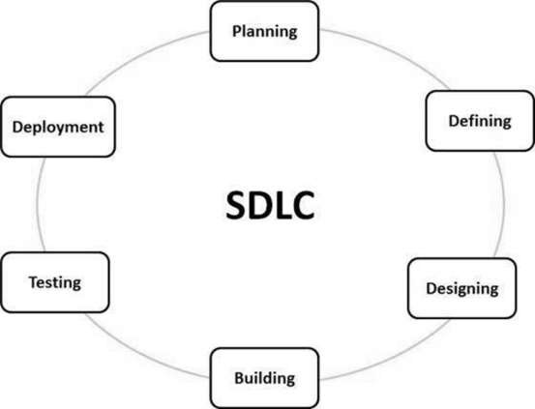

Figure 2: Graphical Representation of SDLC

A typical Software Development Life Cycle consists of the following stages: -

* Planning and Requirement Analysis.
* Defining Requirements.
* Designing the Product Architecture.
* Building or Developing the Product.
* Testing the Product.
* Deployment in the Market and Maintenance.

### Planning and Requirement Analysis.

Requirement analysis is the most important and fundamental stage in SDLC. It is performed by the senior members of the team with inputs from the customer, the sales department, market surveys and domain experts in the industry. This information is then used to plan the basic project approach and to conduct product feasibility study in the economical, operational, and technical areas. Planning for the quality assurance requirements and identification of the risks associated with the project is also done in the planning stage. The outcome of the technical feasibility study is to define the various technical approaches that can be followed to implement the project successfully with minimum risks.

### Defining Requirements

Once the requirement analysis is done the next step is to clearly define and document the product requirements and get them approved from the customer or the market analysts. This is done through an SRS (Software Requirement Specification) document which consists of all the product requirements to be designed and developed during the project life cycle.

### Designing the Product Architecture

SRS is the reference for product architects to come out with the best architecture for the product to be developed. Based on the requirements specified in SRS, usually more than one design approach for the product architecture is proposed and documented in a DDS - Design Document Specification. This DDS is reviewed by all the important stakeholders and based on various parameters as risk assessment, product robustness, design modularity, budget and time constraints, the best design approach is selected for the product. A design approach clearly defines all the architectural modules of the product along with its communication and data flow representation with the external and third-party modules (if any). The internal design of all the modules of the proposed architecture should be clearly defined with the minutest of the details in DDS.

### Building or Developing the Product

In this stage of SDLC the actual development starts and the product is built. The programming code is generated as per DDS during this stage. If the design is performed in a detailed and organized manner, code generation can be accomplished without much hassle. Developers must follow the coding guidelines defined by their organization and programming tools like compilers, interpreters, debuggers, etc. are used to generate the code. Different high level programming languages such as C, C++, Pascal, Java, and PHP are used for coding. The programming language is chosen with respect to the type of software being developed.

### Testing the Product

This stage is usually a subset of all the stages as in the modern SDLC models, the testing activities are mostly involved in all the stages of SDLC. However, this stage refers to the testing only stage of the product where product defects are reported, tracked, fixed, and retested, until the product reaches the quality standards defined in the SRS.

### Deployment in the Market and Maintenance

Once the product is tested and ready to be deployed it is released formally in the appropriate market. Sometimes product deployment happens in stages as per the business strategy of that organization. The product may first be released in a limited segment and tested in the significant business environment (UAT- User acceptance testing). Then based on the feedback, the product may be released as it is or with suggested enhancements in the targeting market segment. After the product is released in the market, its maintenance is done for the existing customer base.

## Software Requirement Specification

### What is SRS?

A software requirements specification (SRS) is a detailed description of a software system to be developed with its functional and non-functional requirements. The SRS is developed based on the agreement between customer/participant and contractors. It may include the use cases of how the user is going to interact with the software system. The software requirement specification document is consistent with all necessary requirements required for project development. To develop the software system, we should have a clear understanding of Software system. To achieve this, we need continuous communication with customers/participant to gather all requirements.

A good SRS defines how the Software System will interact with all internal modules, hardware, communication with other programs and human user interactions with a wide range of real-life scenarios. Using the Software requirements specification (SRS) document on QA lead, managers create a test plan. It is important that testers must be cleared with every detail specified in this document to avoid faults in test cases and its expected results.

It is highly recommended to review or test SRS documents before start writing test cases and making any plan for testing.

### User Sope

Here user means participant on our website.

* Sign up to our website to make their own account.
* Participants can logout from their account.
* Participants can see our blog post.
* Participants can comment on our blog post.
* Participants can attend any quiz test which we provide.
* Participants can edit/update their account.
* Project manager can create room.
* Participants can contact us using contact form.

### Moderator Scope

* Moderator can login to their account.
* Moderators can edit/update their account.
* Moderators can replay participant messages.
* Moderators can edit blog posts.
* Moderator can publish a new post.
* Moderator can make quiz questions paper.
* Moderator can see participant information.

### Admin Scope

* Admin can login to their account.
* Admin can edit/update their account.
* Admin can do all things which moderators can do.
* Admin can add another moderator.
* Admin can see moderator information.
* Admin can delete any question set.

### Constraints And Dependencies

It will be a web-based application and can be runed on any platform that has access to the internet (pc, laptop, mobile, etc.). The internet connection is dependent on the application. Since the application fetches and retrieves data from the database or streams our video tutorial directly over the internet, it is crucial that there is an internet connection for the application to function. The designing criteria will be fulfilled by doing research on which will be the most user-friendly way to design the application for the users.

### User Interface

There are two types of user interface once for frontend and another one for backend. Frontend interface is a web template. Which is made with html5, CSS, JavaScript. It is also called the landing page for our website. In the landing page there are multiple options for participants. Participants can use the contact option to contact us. There is also a chat boat for instant replay.

### Admin Panel Interface

In the backend user interface, which is also called admin panel. Admin Panel used to interact with the database. Admin panels make easy admin or moderator work.

### Communication Interface

The communication between the various parts of the system is important since they depend on each other. However, in what way the communication is achieved is not important for the system and is therefore handled by the underlying operating system for the entire web application. Notification will be generated for helping users do all kinds of things in the system. Participants can use the contact form for contacting us. Also, they can use an auto chat box for instant simple help.

### Project Position in the System Life Cycle

Our website is the beginning of its life cycle. The software development model selected for the web development is a once-through (Scrum Model) strategy. Scrum borrows from Agile’s foundational beliefs and philosophy that teams and developers should collaborate heavily and daily. With Scrum, software is developed using an iterative approach in which the team is front and center experienced and disciplined workers on smaller teams might find the most success with this method, as it requires self-organization and self-management. Team members break down end goals into smaller goals at the beginning and work through them using fixed-length iterations—or sprints—to build software and show-case it often (which usually last two weeks). Meetings play a significant role in the Scrum approach, and during each sprint, daily planning meetings and demos take place to follow progress and gather feedback. This incremental method promotes quick changes and development and adds value to complex projects. Scrum incorporates the structure and discipline of more traditional software development methodologies with the flexibility and iterative practices of modern Agile.

## Testing

### Features to be Tested

Feature testing is an important part of our web application. Feature testing is the process of making changes in a software system to add one or more new features or to make modifications in the already existing features. Aim of Feature testing is verifying that the system is ready for release, works properly or not. It helps developers and testers in detecting bugs at the feature level of the software. If any software is unable to perform the client requirements or execute the chosen functions with accuracy, it may lead to significant loss of money and efforts.

We have tested:

* Participant Sign Up.
* User Login.
* User Logout.
* User editing.
* Participant editing in this system.

We must make sure of accurate understanding of the feature, creating various test scenarios and knowledge of the feature implementation before the testing is done. Testers can track errors and bugs in the features and find ways to correct them. Performing feature testing in the initial stages, the testers can find defects as soon as they are detected and make changes as per the client’s demands.

### Features not to be tested

The list of all the features that are not planned for testing will be listed out.

Example:

* Out of scope features.
* Minimal risk features.
* Future functionality.
* Specific the reason these features will not be tested.
* Not to include these features for software release time.

## Tools And Technology Used

### Apache Web Server

Apache is the most widely used web server software. Developed and maintained by Apache Software Foundation, Apache is an open-source software available for free. It runs on 67% of all web servers in the world. It is fast, reliable, and secure. It can be highly customized to meet the needs of many different environments by using extensions and modules. Most WordPress hosting providers use Apache as their web server software. However, WordPress can run on other web server software as well.

### MySQL Database

MySQL is an open-source relational database management system based on SQL – Structured Query Language. The application is used for a wide range of purposes, including data warehousing, e-commerce, and logging applications. The most common use for MySQL however, is for the purpose of a web database.

### Php

PHP is a server-side scripting language. that is used to develop Static websites or Dynamic websites or Web applications. PHP stands for Hypertext Preprocessor, that earlier stood for Personal Home Pages. PHP scripts can only be interpreted on a server that has PHP installed. The client computers accessing the PHP scripts require a web browser only. A PHP file contains PHP tags and ends with the extension ".php". PHP is open source and free. Short learning curve compared to other languages such as JSP, ASP etc. Large community document. Most web hosting servers support PHP by default unlike other languages such as ASP that need IIS. This makes PHP a cost-effective choice.

### Xampp

XAMPP is an abbreviation for cross-platform, Apache, MySQL, PHP, and Perl, and it allows you to build WordPress sites offline, on a local web server on your computer. This simple and lightweight solution works on Windows, Linux, and Mac – hence the “cross-platform” part.

### Sublime

Sublime Text is a shareware cross-platform source code editor with a Python application programming interface (API). It natively supports many programming languages and markup languages, and functions can be added by users with plugins, typically community-built and maintained under free-software licenses. Using Sublime Text as your IDE. Sublime Text is a fast, powerful, and easily extensible code editor. Sublime can be used on Linux, Windows, and Mac as an IDE for developing Chromium.

### Responsive Template

Responsive Template web design, or RWD, formats a web page layout to be fluid for optimal viewing and navigation across a wide range of devices, including traditional PC and Mac desktop and laptop computers, tablet and surface, smartphones, and all other mobile devices.

### Operating System

An operating system (OS), in its most general sense, is software that allows a user to run other applications on a computing device. The operating system manages a computer's hardware resources, including: Input devices such as a keyboard and mouse. Output devices such as display monitors, printers, and scanners.

### Google Docs

Google Docs is a powerful real-time collaboration and document authoring tool. Multiple users can edit a document at the same time, while seeing each other's changes instantaneously. Users can produce text documents, slide presentations, spreadsheets, drawings, and surveys.

### Día

Día Diagram Editor is free Open-Source drawing software for Windows, Mac OS X and Linux. Día supports more than 30 different diagram types like flowcharts, network diagrams, database models. More than a thousand readymade objects help to draw professional diagrams. Día can read and write several different raster's and vector image formats. Software developers and database specialists can use Día as a CASE tool to generate code skeletons from their drawings. Día can be scripted and extended using Python.

### Microsoft SQL Diagram

SQL diagrams is a powerful tool, before illustrating some of the tasks and issues it would be better to present a list of major concepts. You can only use tables in SQL Server database diagrams. No other SQL Server objects are allowed to be accessed from the diagram editor. Tables in the database diagram are not independent. Any modification in tables through this tool will directly affect the table architecture in the database.

### Browser

Short for web browser, a browser is a software application used to locate, retrieve, and display content on the World Wide Web, including webpages, images, video, and other files. As a client/server model, the browser is the client run on a computer or mobile device that contacts the Web server and requests information. There are four leading web browsers: Explorer, Firefox, Netscape, and Safari but there are many others browsers available. Netscape is one of the original Web browsers. This is what Microsoft designed Internet Explorer to compete against. Netscape and IE comprise the major portion of the browser market.

### GitHub

GitHub is a web-based platform used for version control. Git simplifies the process of working with other people and makes it easy to collaborate on projects. Team members can work on files and easily merge their changes with the expert branch of the project Create Repository in GitHub.

## Work Breakdown Structure and Schedule

Work Breakdown Structure and Scheduling are given below for the project.

### Work Breakdown Structure

|  |  |  |  |
| --- | --- | --- | --- |
| **Action** | **Task Name** | **Duration** | **Predecessors** |
| A | Develop Business case | 1 Week | - |
| B | Assign Project Manager | 1 Week | A |
| C | Develop Project Charter | 1 Week | B |
| D | Perform Primary Planning | 2 Week | B |
| E | Perform Support Planning | 2 Week | B |
| F | Develop Performance Plan | 2 Week | B |
| G | Assign Developers | 1 Week | B |
| H | Manage Procurements | 1 Week | G |
| I | Track and Manage Risks | 1 Week | G |
| J | Website Prototype Design | 2 Week | G |
| K | Landing Page | 1 Week | G |
| L | User Registration/Login/User type | 1 Week | G |
| M | Question Function | 2 Week | G |
| N | User Profile | 1 Week | G |
| O | Team profile | 1 Week | G |
| P | Team Room | 2 Week | G |
| Q | Design and Create Other Pages | 2 Week | P |
| R | Manage Changes | 3 Week | P |
| S | Test the system | 2 Week | P |
| T | Documentation Closeout | 1 Week | S |
| U | Transfer Project | 1 Week | T |

### Schedule

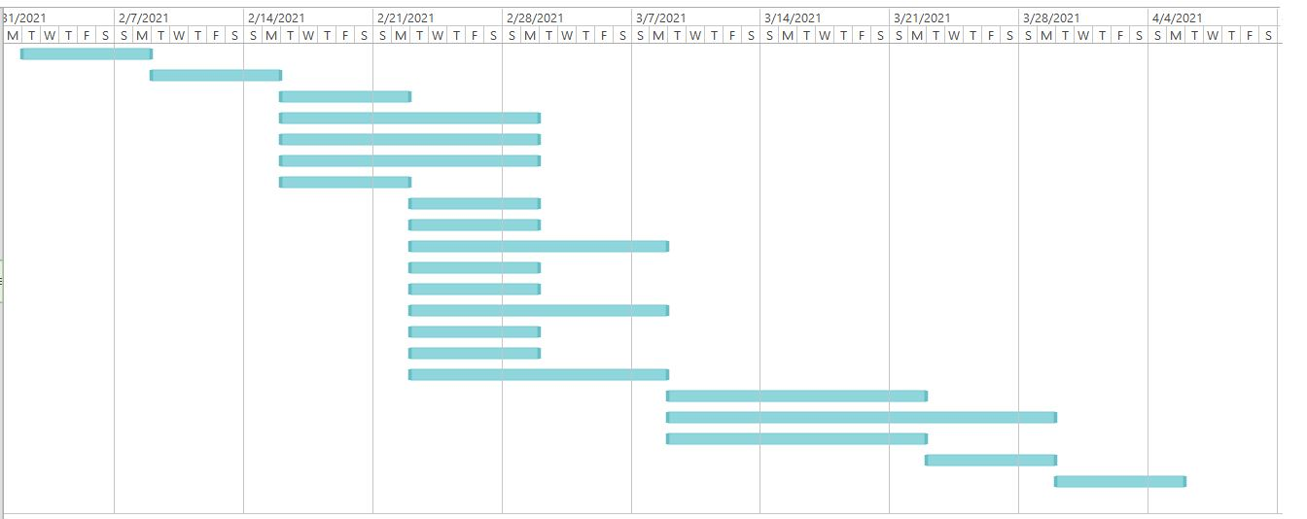

# Marketing Plan

## Define goals

We have more than one main goal for our online marketing: -

* We want to draw the attention of all software companies.
* Want to influence students to try.

## Target audience

Our application is not for everyone. It is related to project buildup and team work. So, our target audiences are students and employees who are doing projects and making group to work as a team.

Here are some things which indicates our target audiences: -

* Age (15 or above)
* Gender (Both Male & Female)
* Education level (College or Undergraduate or above)
* Occupation (Students or Employees)
* General interests (Project Buildup, Team Work)

But there is no restriction for anyone to enter and use the application as it is a phycological test.

## Marketing Tactics

For our system we have chosen two types of marketing tactics: -

* Email marketing.
* Social media marketing.

We have chosen these two marketing tactics because every employee and every student have both personal and organizational email address. So, if we use that we can reach to every employee and student and might get a good response. Besides nowadays everyone uses social media (Facebook, Tweeter, Instagram). So, it is also an effective way to reach the target audiences.

# Cost and Profit Analysis

## Cost Analysis

Our web application is the simplest version of a web application with basic functionality. Its development Time is around 8 to 9 weeks (about 2 months).

* Approximate Development Cost is $5000 to $7,000.
* Approximate Marketing Cost is: -
  + Email marketing cost is $300 - $5,000/month or $0.1 - $0.5/email.
  + Social media marketing cost is $250 - $10,000/month.

## Profit Analysis

|  |  |
| --- | --- |
| **Event** | **$ In/Out** |
| Initial Investment by ABC Company | + $10,000 |
| Development Cost | - $6,000 |
| Email marketing cost | - $700 |
| Social media marketing cost | - $1,000 |
| Previous month sales | + $1,000 |
| Total | + $3,300 |

# Conclusion

Team Building is the most crucial factor that decides the overall success of any organization or web application like us. Working with other people does not mean that working as a team. Real teamwork implies collaboration, communication, and acknowledgment of a common purpose. Hence, a group is more than just a gathering of people, and not all groups are teams. Teams are, in fact, a very particular kind of group in that they are interdependent and focused on structure and activities. At a minimum, a team should be a cooperative unit and, at its best, a team is a collaborative unit.” Intuitively, we know thatcommunication is an essential factor for a group of people working together. It provides feedback and guidance on how well each of the team members listens, encourages participation, and discusses sensitive topics. We try our best to follow the above rules.

In the next phase of our web application, we try to test some more important thing which is:

* We build an android app for android mobile devices. Which also uses the same database so that our system will act dynamically.
* We try to test our phycological books and eBook's section.
* We try to make a consulting session with those participants who need this. So, in this case we need a video streaming test.

# Referenced Documents

List of all documents that support this project plan. Refer to the actual version/release number of the document or books as stored in the configuration of various websites. There is no duplicate text from other documents. Documents that can be referenced include bellow:

1. G. O. Michaels, “The 11 low of Likability,” in Plastics, vol. 3, Power of human psychological test, J. Peters, Ed., 2nd ed. New York, NY, USA: McGraw-Hill, 1964, pp. 15–64. [Online]. Available: <http://www.bookref.com>.
2. D. Caratelli, M. C. Viganó, G. Toso, and P. Angeletti, “Analytical placement technique for human behavior,” presented at the 32nd ESA Mind Architecture Workshop, Noordwijk, The Netherlands, Oct. 5–8, 2010.
3. Process Psychological Test Corp., Framingham, MA, USA. Intranets: Internet technologies reduce our emotion and natural productivity. Presented at INET’96 Annu. Meeting. [Online]. Available: http://www.process.com/ Intranets/wp2.htp.
4. J. Barney. (2011). Documenting survey about natural human mentality [PowerPoint slides].
5. J. Smith. “Abrahem inaugurated as President of Mental City Hospital.” CNN.com. http://www.cnn.com/POLITICS/01/21/obama_inaugurated/index.html